# Vessel Research

We have different types of vessels. Usually, the bigger the ship, the more forward the control bridge is positioned.

Their sizes are based on the Panama's canal width, hence the names Panamax and Post-Panamax.

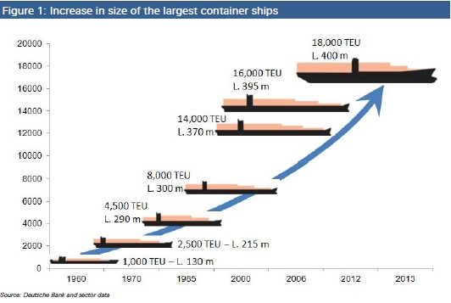

Along the years the size has been increasing.

## Containers

Containers have become the main way of transporting manufactured goods around the world. A container can be transferred between truck, train and ship relatively easily and is a standard size to simplify transportation. Containers can accommodate anything from foodstuffs to electrical equipment to automobiles. They are also used to transport bagged and palletised goods, as well as liquids and refrigerated cargo.

Standard containers are measured as TEUs (Twenty-foot Equivalent Units) and are generally 20 feet (1 TEU) or 40 feet (2 TEUs) long. All standard shipping containers are 8 feet wide and 8 feet 6 inches tall. There are also longer, taller and even shorter standard sizes, but these are less common. Each 20 foot container has the following dimensions:

**6.10m long x 2.44m wide x 2.59m high**

## Container Ships

Container ships are made up of several holds, each equipped with “cell guides” which allow the containers to slot into place. Once the first layers of containers have been loaded and the hatches closed, extra layers are loaded on top of the hatches. Each container is then lashed to the vessel but also to each other to provide integrity. Containers are usually loaded by specialized cranes or even general purpose cranes with container lifting attachments. Some small container vessels are geared to allow self-loading and discharging.

Container vessels are used predominantly on liner routes and are some of the biggest vessels afloat. Ultra Large Container Vessels (ULCVs) such as the Emma Maersk (lead ship of the Maersk E-Class vessels) can carry approximately 15,000 TEU (depending on container weight). Large container vessels are restricted by their size to certain ports around the world and are also unable to transit certain areas due to draft or, in the case of canals, beam restrictions.

We have, in terms of control bridge positioning, three types of vessels:

The ones with the bridge in the stern:

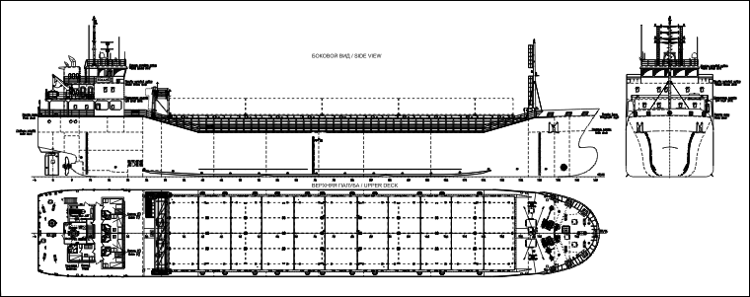

Figure 1 - Cargo ship with stern control bridge

The ones with the bridge in the midship (not exactly there but between the bow and the stern):

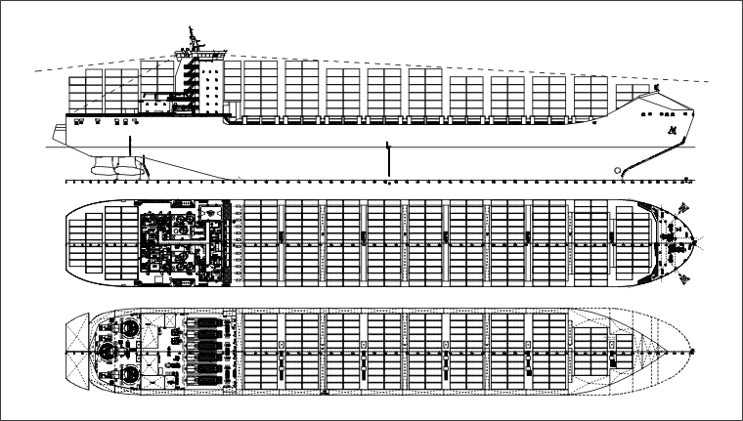

Figure 2 - Cargo ship with "midship" control bridge

The ones with the bridge in the bow:

Figure 3 - Cargo ship with bow control bridge

And, there are some of those that do not even have a control bridge as usual, due to the fact they are non-propelled:

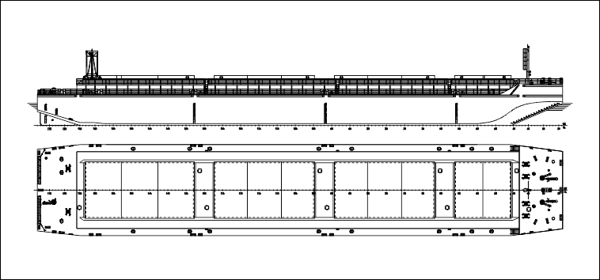

Figure 4 - Non-propelled cargo ship

Considerations to take with the vessel sketch:

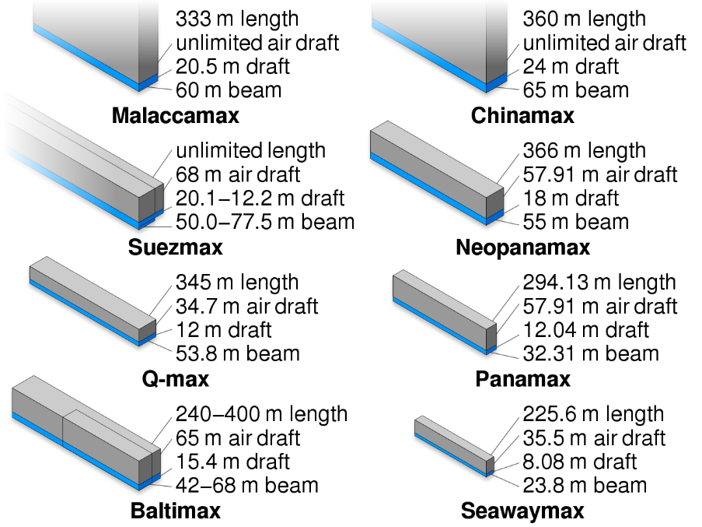

Figure 5 - Dimensions of each vessel type

Let us consider the Panamax as a good example for us to make our sketch. Let’s also round up the dimensions so that we can get cleaner results out of our calculations.

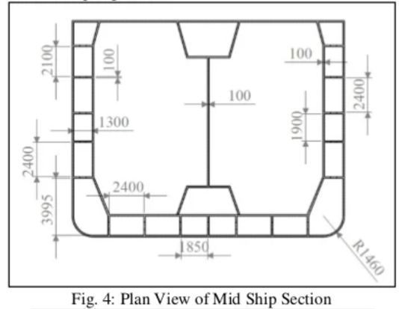In terms of steel thickness of the structure, we can take in example the following midship section:

Figure 6 - Midship section example

This means that, in terms of steel thickness, we have around 20/25 cm. Lets consider, for simplification purposes, 25 cm. This is due to the fact we do not have a continuous steel frame, we have the frame and then we have a structure that connects to an interior structure. The thickness of it is “just” 100 mm on the exterior wall and 100 mm in the interior wall but it has connections between them of 1.5 m long with 100 mm thickness as well, hence the 5 extra cm we are considering.

## Centre of mass calculations:

### Centre of mass theory and formulas:

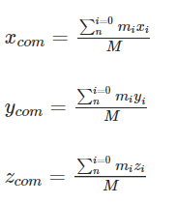

These formulas consider regular shapes where you can determine points based on coordinates.

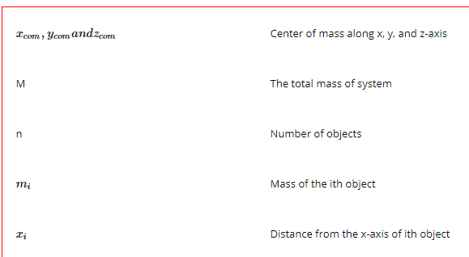

Following this formula, we can determine the location of the centre of mass of a given object divided into various geometrical shapes. For better understanding, follow the next video:

<https://www.youtube.com/watch?v=ufPysPtpYxw>

The tricky part here would probably be calculating the mass. But since we are considering that the vessel is made of the same material, it will be uniform.

We will only need to calculate the volume of each shape we consider and multiply it by the density of the material considered:

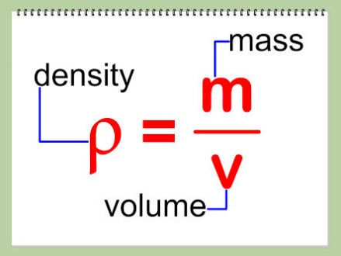

After that we just do the calculations and determine the centre of mass.

Let us consider this as our ship. Obviously, it has approximate shapes and does not take into consideration every curve and shape of the real ship:

Figure 7- 3d model of the considered ship

Figure 8- 2d drawing of the ship with dimensions

Through developed code we arrived to the result of:

X = 144.04256 m

Y = 16.0 m

Z = 16.06383 m

We can reach the conclusion that the result is correct as we follow these steps:

$$X=\frac{m1x1+m2x2}{m1+m2}$$

$$Y=\frac{m1y1+m2y2}{m1+m2}$$

$$Z=\frac{m1z1+m2z2}{m1+m2}$$

It is important to define m1 and m2:

$$m1= ρ1* V1$$

$$m2= ρ2* V2$$

Since the density is the same for both, we can consider the following:

$$ρ1= ρ2=7000 kg/m3$$

In a way it is irrelevant for us to define the density of the material as it is uniform per the entire ship but, to still have a reality factor in the calculations, we set the density similar to a High Tensile Steel density, 7000 kg/m3.

The volume of each prism is correspondent to their Length x Width x Height, so:

$$V1=300*32*30=288000 m^{3}$$

$$V2=20*32*20=12800 m^{3}$$

So: $$m1= 7000*288000=2.016x{10}^{9} kg$$

$$m2= 7000*12800 =8.96x{10}^{7} kg$$

The centre of mass of each solid (considering the origin point as the ship’s base inferior vertex under the control bridge) is:

$x1=\frac{300}{2}+Dx1=150 m$ $y1=\frac{32}{2}+Dy1=16 m$ $z1=\frac{30}{2}+Dz1=15 m$

$x2=\frac{20}{2}+Dx2=10 m$ $y2=\frac{32}{2}+Dy2=16 m$ $z2=\frac{20}{2}+Dz2 =40 m$

Dx, Dy and Dz are the distances considered from the system’s origin to the prism’s origin.

Since X and Y are coincident with both prisms, only the Z (height axis) will have a value, in this case 30 since it is equal to the height of the ship’s base.

Figure 9 - Ship's system origin

Since we now have all of the values needed, we can calculate the system’s centre of mass:

$$X=\frac{2.016*{10}^{9}*150+8.96*{10}^{7}*10}{2.016*{10}^{9}+ 8.96*{10}^{7}}= 144.04256 m$$

$$Y=\frac{2.016*{10}^{9}*16+8.96*{10}^{7}*16}{2.016*{10}^{9}+ 8.96*{10}^{7}}= 16 m$$

$$Z=\frac{2.016*{10}^{9}*15+8.96*{10}^{7}*40}{2.016*{10}^{9}+ 8.96*{10}^{7}}= 16.06383 m$$

Comparing with the results collected from the program, we can conclude it is well calculated. 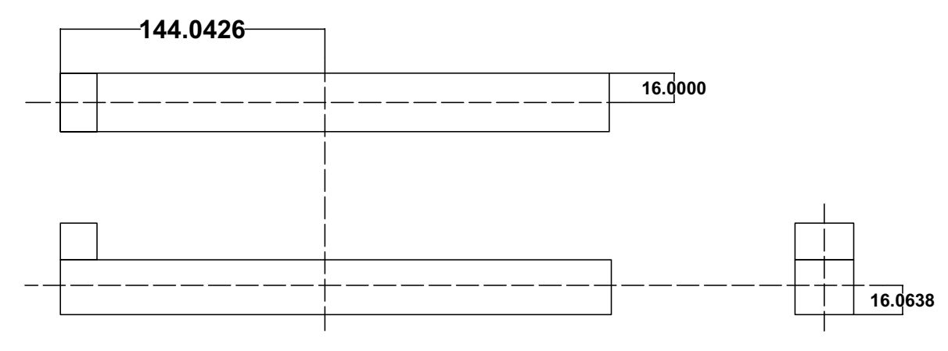

Figure 10 - Geometrical location of the centre of mass

# Container Placement

If the objective is to maintain the centre of mass of the ship in the x and y axis, we must position the first container of all with its centre of mass coincident with the ship’s centre of mass in the x and y coordinates. Then we can simply add one on each side the container, maintaining the ship as symmetrical as possible.

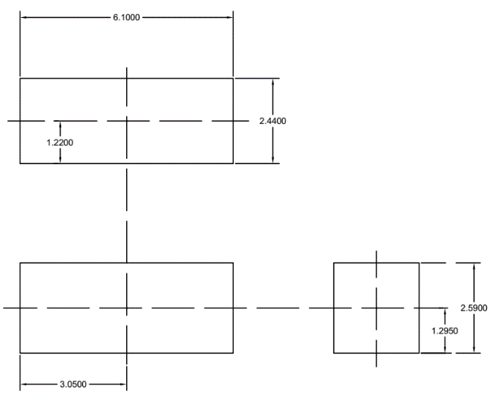This is our container example:

Figure 11 - Container Drawing

The thought process behind the distribution of the containers was the following:

Figure 12 - First Container to be positioned on the ship

If we create a distribution of a spiral starting from the centre mass projected on the deck, we will be able to maintain centre of mass always around the point where it is at the start. Obviously it will have some small variations due to the fact that the balance in the spiral is dependent on the number of containers.

Regarding the produced code for this distribution, initially I began by creating a matrix with the maximum allowed containers on the deck, considering where the centre of mass is positioned, the difference between that centre and the limits and origin of the deck. We must have a matrix as symmetric as possible.

After that we fill a matrix with 0’s and 1’s whether there isn’t or is a container positioned in there. The algorithm is adapted to MxN matrices. A Spiral distribution will always work perfectly on a NxN matrix but in here it needs adaptations.

For better understanding, run the tests, compare the results obtained and check the Javadoc that was produced for every method.

The same goes for the methods developed to obtain the exerted pressure and the height of the ship that is underwater, or as it is called formally, the wet draft.

Figure 13 - Position of 100 Containers on top of the deck

With the produced code, the result obtained for 100 containers will be the one in the Figure 13. One can obviously point out that it is not exactly symmetric but, as stated in the above text, that is the “danger” of choosing a solution based on spiral distribution.

## Calculation of pressure exerted and wet draft

The concept of pressure is simple. Pressure is a force that is applied on a certain area:

$$P=F*A$$

In the calculations we are making, we are not taking into consideration many other forces, the drag force of the water, the air drag force for example. In this case, we can consider that the Pressure the ship is exerting on the water is caused by its own weight:

$$Fg=m*g$$

Where m is the mass/weight of the ship with or without the containers.

The area considered here will only be the base of the ship, as the force caused by the weight has its direction downwards to the centre of gravity of the earth.

In this case we will have:

$$P=(FgVessel+FgContainers)*AshipBase$$

$$P=\left(\left(SteelVolume*SteelDensity+AirVolume*AirDensity\right)*9.81\right)+500*9.81)*(300*32)$$

$$P=(\left(2.19E9+2636938\right)+9810000)*(9600)$$

$$P=21214.258 GPa$$

We are not taking into consideration the Atmospheric pressure since it is somewhat irrelevant when compared to these values.

The wet draft can be calculated through the balance of Forces in the system. The acceleration is 0, so, the resultant Force is 0, so, it means the gravitational force is equal to the buoyant force:

$$Fg=B$$

$$Fvessel+Fcontainers=B$$

The buoyant Force is responsible for countering the force exerted on the sea due to big changes in the density of the mean where the object is positioned. The air’s density is 1 kg/m3.

The sea water’s density is 1026 kg/m3.

The Vessel, in realistic terms, cannot all be considered as a homogeneous material. A huge part of it must be filled with only air. The thickness of the ship's walls must be around 30 cms probably, otherwise the ship would be so extremely dense that it would immediately sink.

$$FgVessel = FgSteel + FgAir$$

$$FgSystem = FgVessel + FgContainers$$

$$B = Density Of Sea Water * Ship base^{'}s area * wet Draft * g$$

$$wet Draft = FgSystem / (density of sea Water * Ship base's area * g)$$